Minmax Tree

- Minimax is an optimization strategy wherein an agent generates the moves it can make, looks into the future and considers what moves its opponent could make in turn, and then repeats for a certain number of levels. It ultimately selects the move that will be best not just for the immediate future, but several turns in advance.

- Alpha beta pruning is a method to expedite this. If certain branches are examined that we know will be worse than previously examined branches, then there is no need to look further.

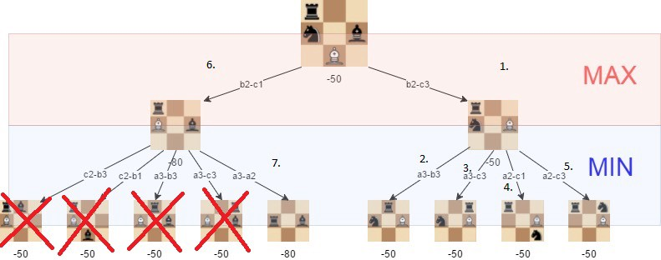

- For our purposes, these techniques were a straightforward way to strengthen our AI’s performance that fit logically into the matter at hand- that being an environment which is strategic, discrete, static, and fully observable.

https://medium.freecodecamp.org/simple-chess-ai-step-by-step-1d55a9266977

